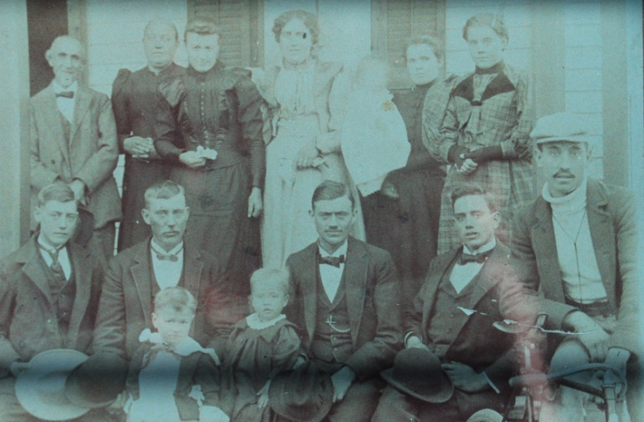

(l-r) Top Row: John P. List, Sophia, Anna, Kate, Mary Cline

Bottom Row: George, ?, Will, Jim, Adam (bicycle) – about 1900 (est.)

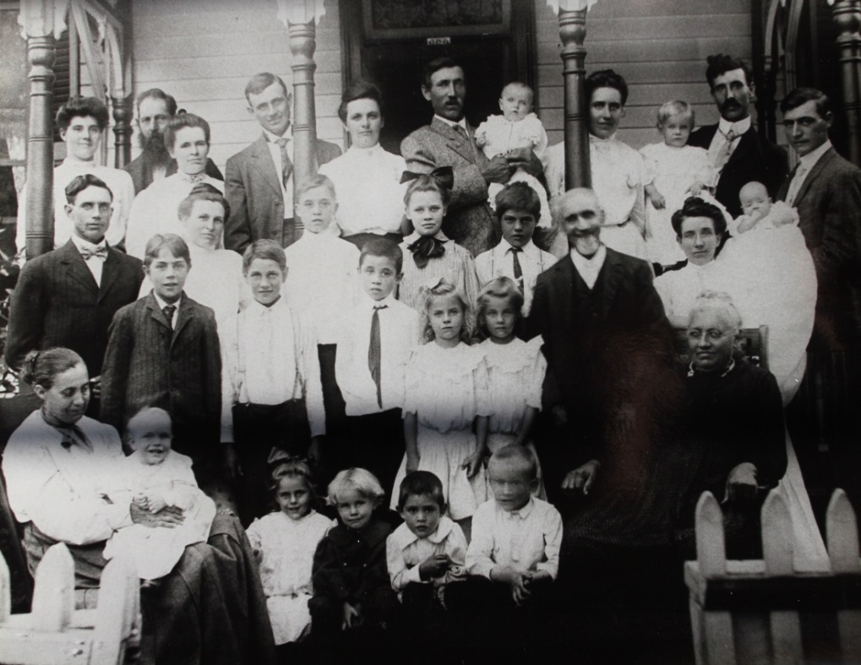

(l-r) Top Row: Mary List Kline, J. Reeves Hulse (husband of Henrietta “Etta” List Hulse),

Kate and Will List, Nellie and Charles List – holding Harvey, Annie List Follrod, Adam List – holding Lester, George List – holding Martha in long dress.

Next Row: Jim and May List, Willie and Flo (Will’s children), Van Meter “Meek” Hulse, John P. List, Etta Weakley List (George’s wife).

Next Row: Edward Hulse, Fred (probably George F.) Hulse, Loring (Will’s son), Verna and Irene (Adam’s children), Sophia List

Bottom Row: Henrietta “Etta” List Hulse – holding Julius Hulse, Bertha Hulse, Kenneth, Bernard and Connor (Will’s children). – about 1907 (est.)